iFiber Y
USB3.2 A+C to C AOC cable

Datasheet V1.0

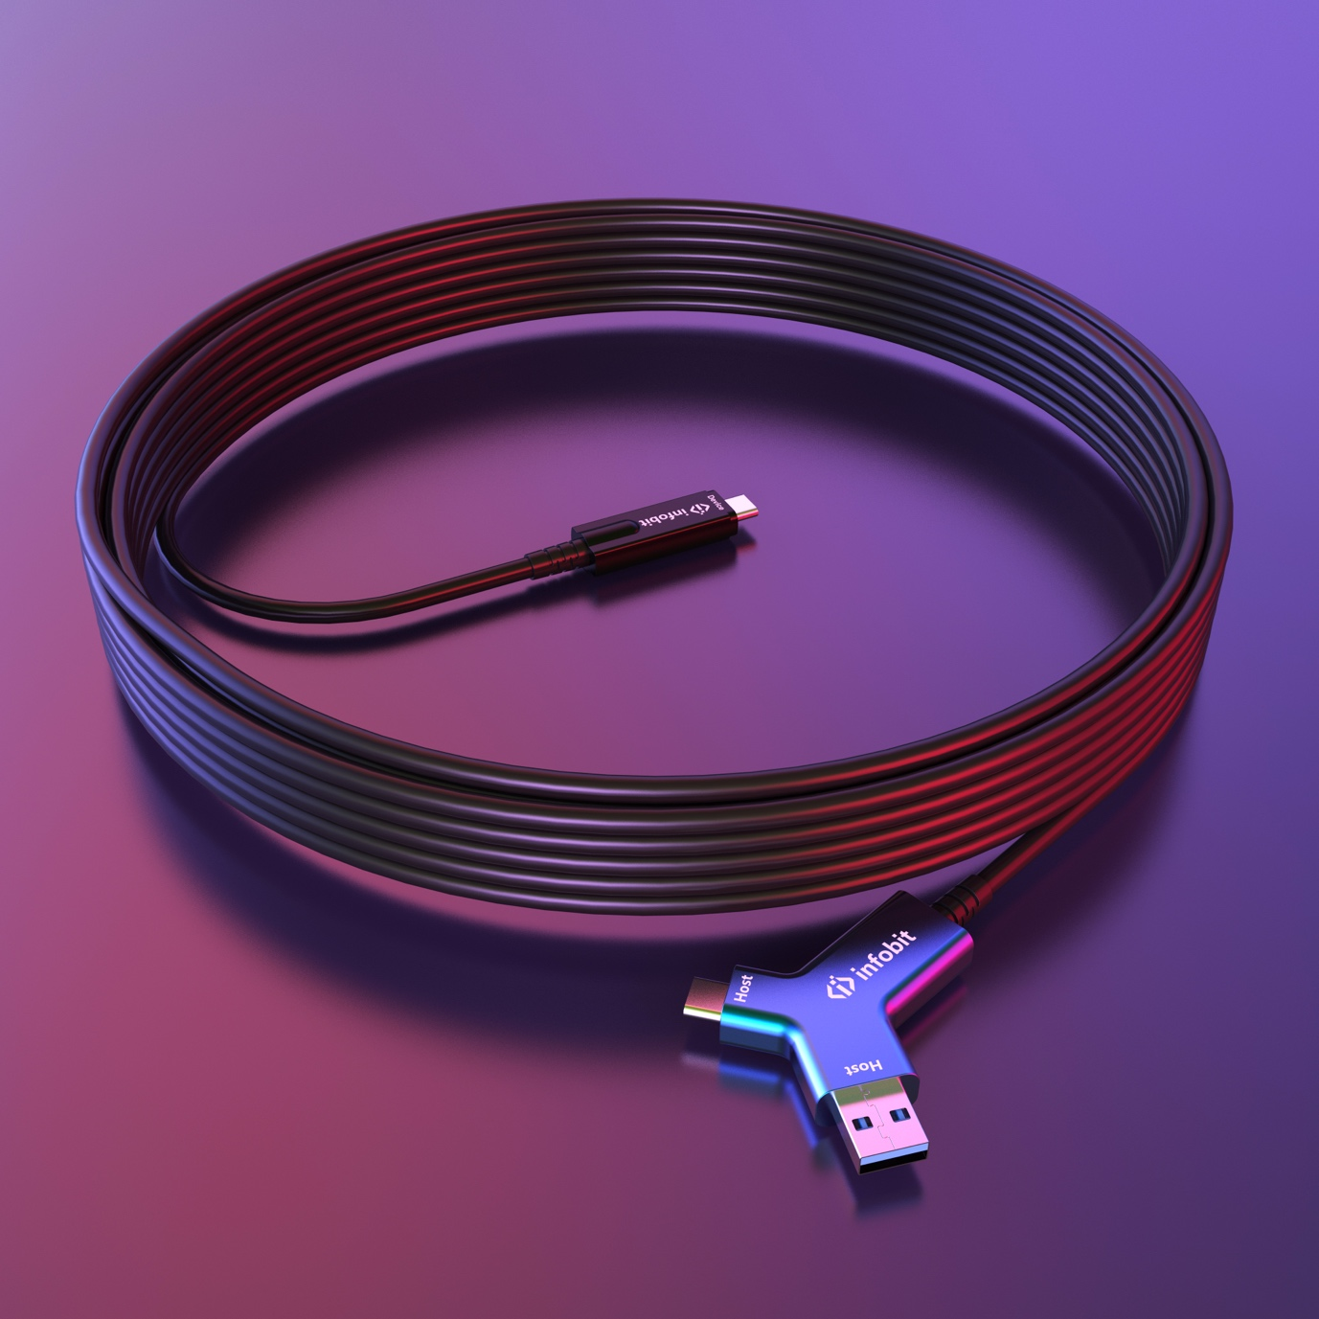

Table of Contents
1. Overview 3
2. Features 3
3. Datasheet 4
4. Cable dimension 5
5. Tested devices 5
6. Models 6

1. Overview

The INFOBIT iFiber Y USB active optical cables are designed to be compliant with SuperSpeed USB and SuperSpeed+ USB electrical specifications, offering seamless interoperability between existing USB 2.0 and USB 3.x hosts, hubs and devices, ensuring a trouble-free plug-and-play experience.

The USB AOC address the growing need for bandwidth with plug-and-play links to existing electrical connectors that scale greater distances than previously possible over copper links. Supporting the latest USB standards, the AOCs are ideal for AR/VR, cameras for conference rooms and machine vision, storage, and other computer peripherals.

Our cables are available in multiple flavors all-in-one set, from standard Type-A to the new Type-C connectors – with the same features and functionalities as traditional copper cables, but at longer lengths.

2. Features

Small-factor USB C head
The USB C device head, designed for commercial installation in walls, above ceilings, through raceways, and within conduit, these long USB cables deliver speeds up to 10Gbps.

Reliable performance
Unlike ordinary USB copper cables, INFOBIT iFiber Y is built to last. With 200 newtons of tensile strength and a 1000 kg crush load, iFiber Y provides reliable performance for peripherals like conference cameras, touch controllers, and powered USB hubs.

Y you must need it?
The iFiber Y is designed with a “Y” shape of both USB A and C at the host head. To join or host a video meeting, simply plug the iconic Y connector into any laptop with a either Type A or Type C port, compatible with all PC models.

High combability
The iFiber Y works with cameras, microphones, speakerphones of brands of INFOBIT, Logitech, Poly, Aver, Huddly, Bose, Neat, Yealink, Jabra and more.

Long distance
Available in lengths of 10, 25, and 40 meters, the iFiber Y cables connect PCs, Macs, and Chromebook to self-powered USB devices and hubs, including cameras, microphones, speakerphones, USB storge, printer, keyboard/mouse and more KVM devices.

3. Datasheet

Model | iFiber Y
Name | USB3.2 A+C to C AOC cable
USB standard | USB3.2 Gen2, 10Gbps, compatible with USB 2.0 and USB 1.1
Length | 10m, 25m, 40m
Power | 5V max
PD | Without Power Delivery
Host | USB Type A Male + Type C Male
Device | USB Type C Male
Tensile strength | 200 newton
Plenum Rated | Yes
Minimum bend radius | 25mm
Cable construction | 2C*OM2 + 1P*24AWG +2C*24AWG
Works with Self-Powered Devices and Hubs | Yes
Works with Bus-Powered Devices and Hubs | No
Storage temperature | -5 to 85 ℃
Operating Temperature | 0 to 50 ℃
Humidity | 0 to 85% RH
Jacket | PVC
Color | Black
Compatible brands* | INFOBIT, Logitech, Poly, Aver, Huddly, Bose, Neat, Yealink, Jabra and more

*Note: the compatible brands list is updated time to time without any prior notice, for updated list, please contact us via info@infobitav.com

4. Cable dimension

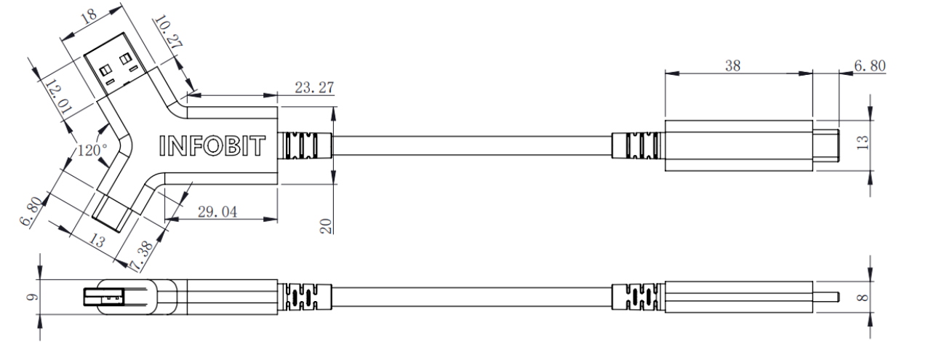

5. Tested devices

Brand | Model | Brand | Model
INFOBIT | iCam VB50 | Yealink | UVC40
INFOBIT | iCam VB60 | Yealink | UVC84
INFOBIT | iCam VB70 | Yealink | UVC86
INFOBIT | iCam P20/ P20N | Logitech | Rally Camera
INFOBIT | iSpeaker M400 | Logitech | Rally Bar
INFOBIT | iSpeaker CM800 | Logitech | Rally Bar Mini
INFOBIT | iSpeaker A20 | Logitech | Meet Up
INFOBIT | iSpeaker CM710 | Aver | CAM570
INFOBIT | iCam 200 | Aver | VC520 Pro2
Huddly | Huddly L1- USB to PoE Adapter | Poly | Studio X30
Huddly | Huddly IQ | Poly | Studio X50
Huddly | Huddly GO | Poly | Studio USB
Bose | VB1 | Poly | Studio E70
Bose | VB-S | Jabra | Panacast 20
Neat | Neat Bar | Jabra | Panacast 50
Neat | Neat Bar Pro

*Note: the actual testing list will be updating time to time without any prior notice, for updated list, please contact us via info@infobitav.com

6. Models

Model | Description
iFiber Y10 | USB 3.2 A+C to C Active Optical Fiber Cable, 10Gbps, 10m/33ft.
iFiber Y20 | USB 3.2 A+C to C Active Optical Fiber Cable, 10Gbps, 25m/82ft.
iFiber Y40 | USB 3.2 A+C to C Active Optical Fiber Cable, 10Gbps, 40m/131ft.

